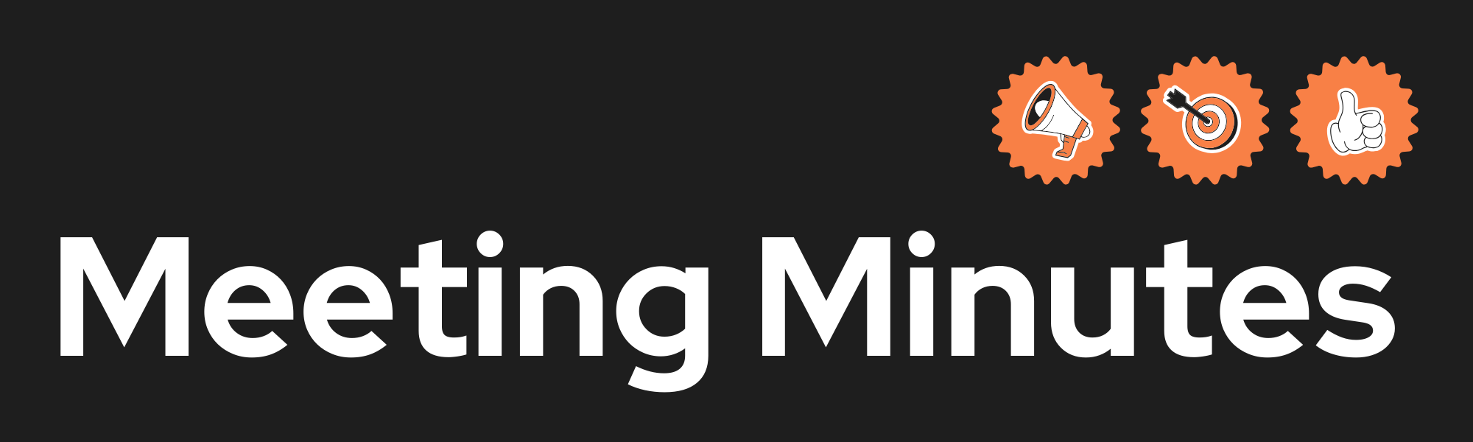
Date and Time
Project Name
Meeting Goal | Get sprint 2 submission ready
Facilitator
Note taker
Attendees
Roundtable Updates (each group member to contribute)
Discussion points | Who is going to take responsibility for the sprint 3 artefacts ie.  - user stories  - Use case diagram  - Wireframes  - Activity diagrams  How are you going to prepare for the final submission?
Actions (list tasks and assign a group member)

